R.R.I.C. ASSOCIATES, INC.
5215 SIMPSON FERRY ROAD SUITE 102
MECHANICSBURG, PA 17050
717/766-9621 800/774-2462
FAX: 717/796-9251
rricassociates@aol.com

- - - - - - - - - - - - - - - - - - - - - - - - - - - - -

ONE MSO ROTARY TRANSER MACHINE, 1995

Stock Number: 2454

Serial Number: 9531534

Cost: $ 14,500.00

Description

TWO JAW CHUCKS
21C COLLET SYSTEM
THREE VERTICAL HEADS
TWO HORIZONTAL HEADS
TAPPING SPINDLE
TWO JACOBS CHUCKS
SPARE GEARHEAD FOR DRIVING THE TABLE
SPARE MAIN DRIVE MOTOR, USED
COMPLETE GUARDING
COMPLETE ELECTRICS

CONDITION - GOOD OPERATING CONDITION

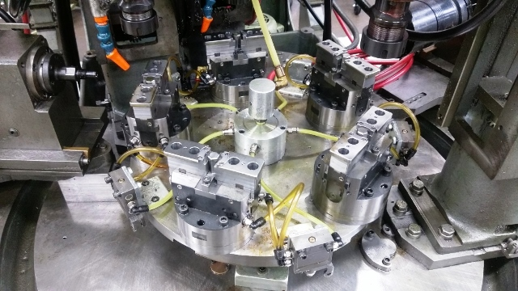

Photographs of Equipment:

